**Dim_customers table**

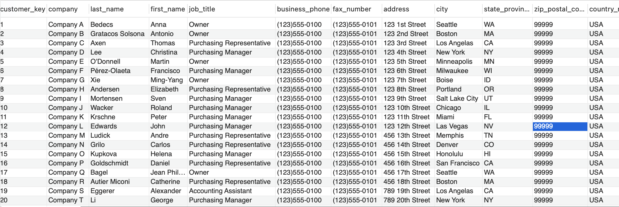

**Dim_employees**

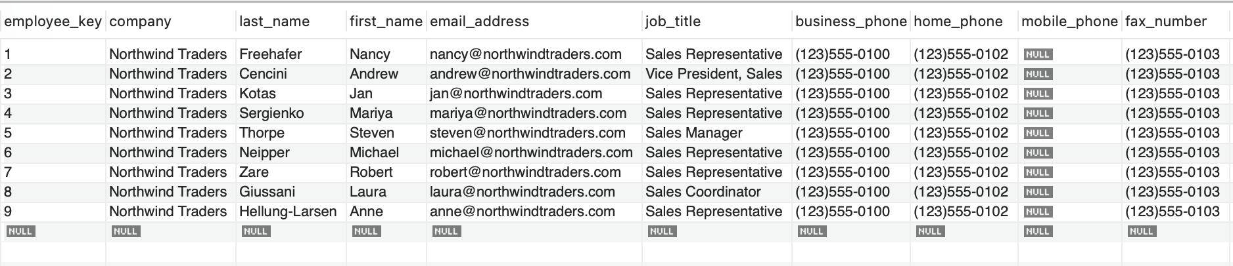

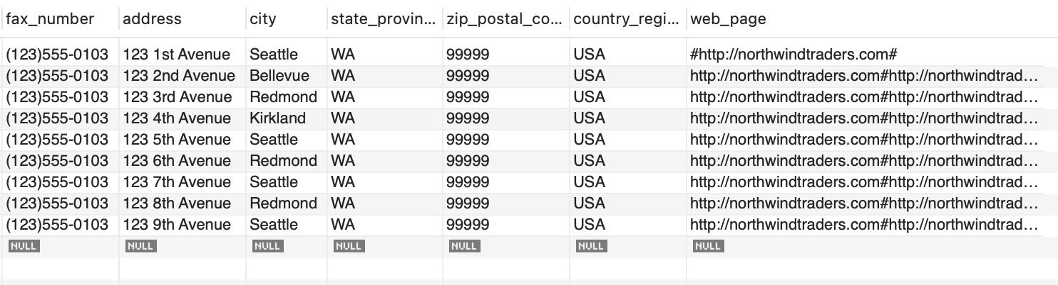

**Dim_products**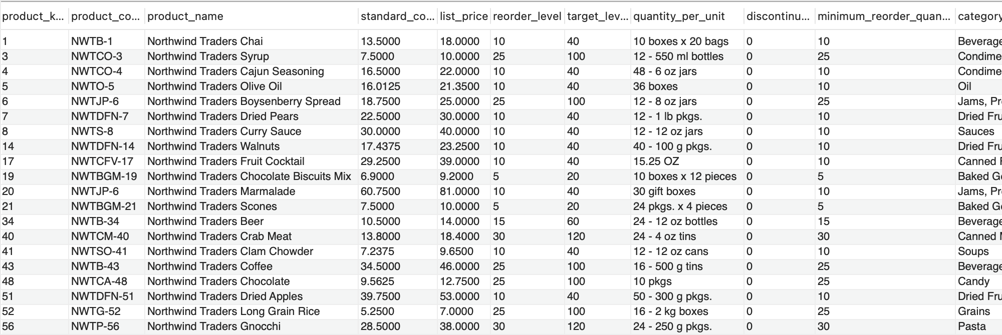

**Dim_shippers**



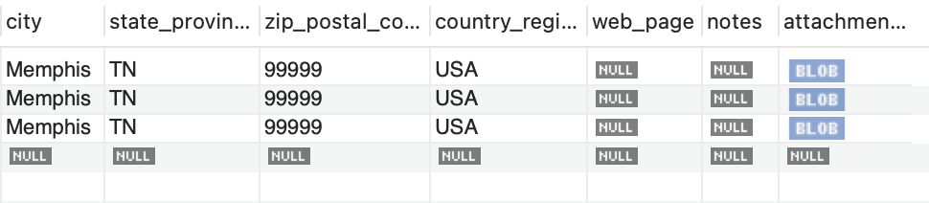

**Query Results**

